SIMATS ENGINEERING
CO3 - ASSESSMENT TOOL - 1: Experiments

COURSE NAME: Cloud Computing and COURSE CODE: CSA1507
Big Data Analytics

Name | Harsita Ashok
Register Number | 192521086

COURSE OUTCOME COVEREDCO3: Implement cloud-based solutions using cloud storage, web
APIs, and platform services for real-world applications. (BL3) Assessment Tool Weightage: 40%

Dave's Taxonomy: Precision (Level 3) Total Marks: 40
Question Count: 4

Duration : 60 Minutes

Code of Conduct
I Harsita Ashok(192521086) certify that this submission is my original work and that I have adhered to the guidelines specified for this assessment.
I understand that any violation of academic integrity rules will result in disciplinary action. Signature of the student: Harsita Ashok

Experiments Rubric
Criteria | Weightage | Level 4 -  Exemplary | Level 3 -  Proficient | Level 2 -  Developing | Level 1 -  Beginning
Experimental Design | 25% | Design is systematic and technically strong | Mostly correct design | Basic design with gaps | Poorly designed activity
Use of Tools /  Platforms | 20% | Appropriate and effective use of cloud tools | Good tool usage with minor issues | Limited tool usage | Incorrect or missing tool usage
Application of  Concepts | 20% | Concepts are applied accurately to practical tasks | Mostly accurate application | Partial application | Weak application
Analysis and  Output | 20% | Strong analysis and meaningful outcome  interpretation | Good analysis with minor gaps | Basic analysis | Little or no analysis
Documentation | 15% | Clear, structured, and complete documentation | Mostly complete documentation | Partially complete | Poor documentation

Total Marks Awarded:
Assessment Tasks
Experiments

Experiment 1: Create a simple cloud software application for Library book reservation system for SIMATS library using any Cloud Service Provider to demonstrate SaaS include the necessary fields such as Title of the book, author, publications, Year, edition, no of copies, Rack no, status (taken/returned) etc.

Experiment 2: Create a simple cloud software application for Payroll Processing System using any Cloud Service Provider to demonstrate SaaS include the necessary fields such as Name of the employee, experience in present org , over all experience, basic pay, HRA, DA, TA, net pay, gross pay etc.
Experiment 3: Demonstrate virtualization by Installing Type-2
Hypervisor in your device, create and configure VM image with a Host Operating system (Either Windows/Linux). Create a Virtual Machine with 1 CPU, 2GB RAM and 15GB storage disk using a Type 2
Virtualization Software.

Experiment 4: Demonstrate virtualization by Installing Type-2
Hypervisor in your device, create and configure VM image with a Host Operating system (Either Windows/Linux). Create a Cloning of a VM and Test it by loading the Previous Version/Cloned VM
1) Create a simple cloud software application for Library book reservation system for SIMATS library using any Cloud Service Provider to demonstrate SaaS include the necessary fields such as Title of the book, author, publications, Year, edition, no of copies, Rack no, status (taken/returned) etc.

AIM:
To create a simple cloud software application for Library Book Reservation System for SIMATS Library using any Cloud Service Provider to demonstrate SaaS.

PROCEDURE:
STEP 1: Log into zoho.com.

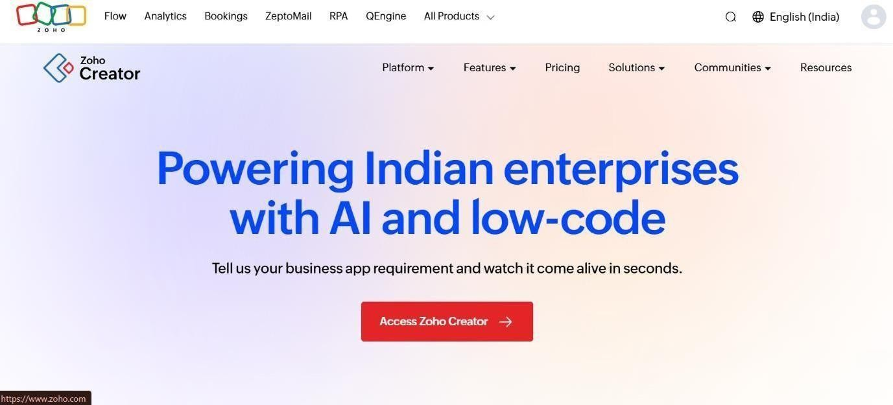
STEP 2: Create a new application from scratch in Zoho Creator.

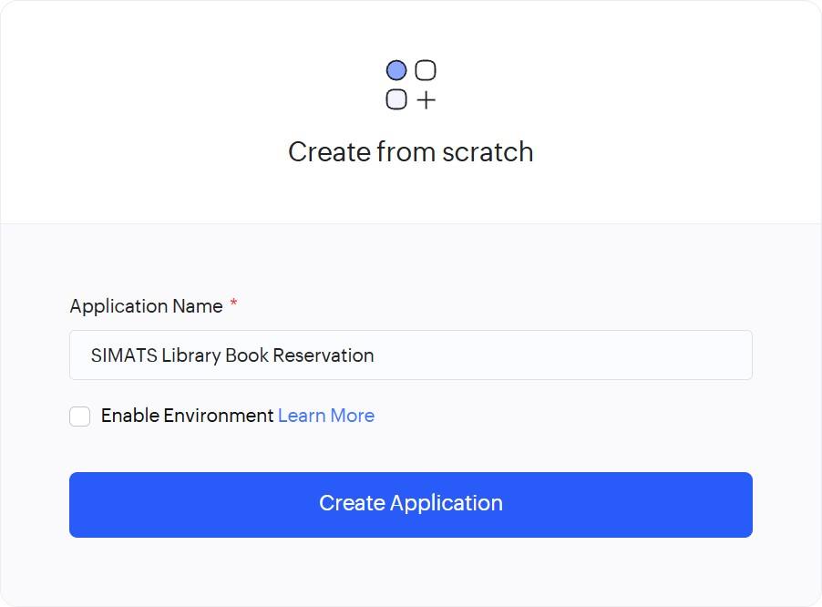

STEP 3: Create a new application and create forms from scratch.

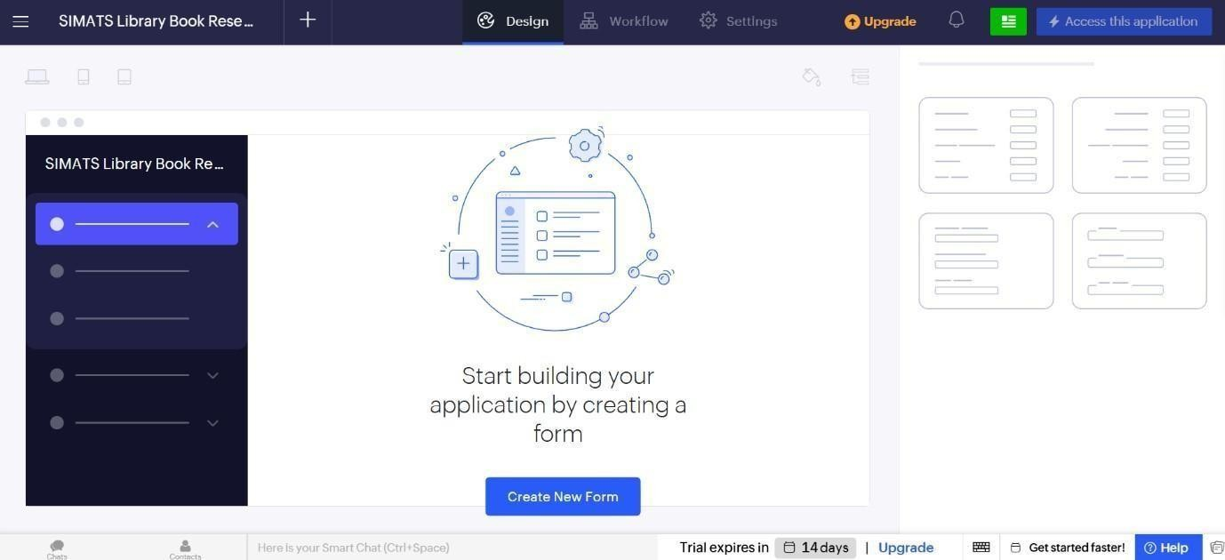
STEP 4: Create Book Details Form.
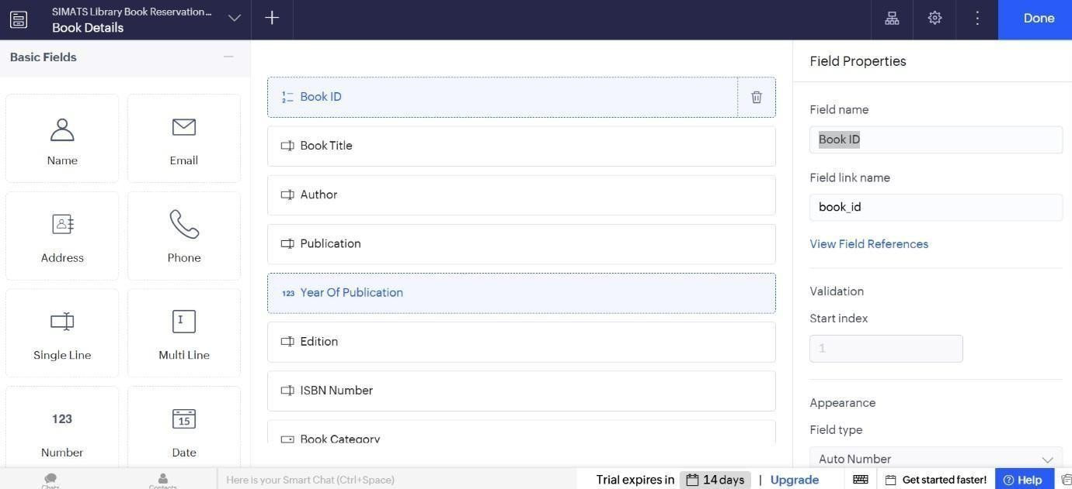

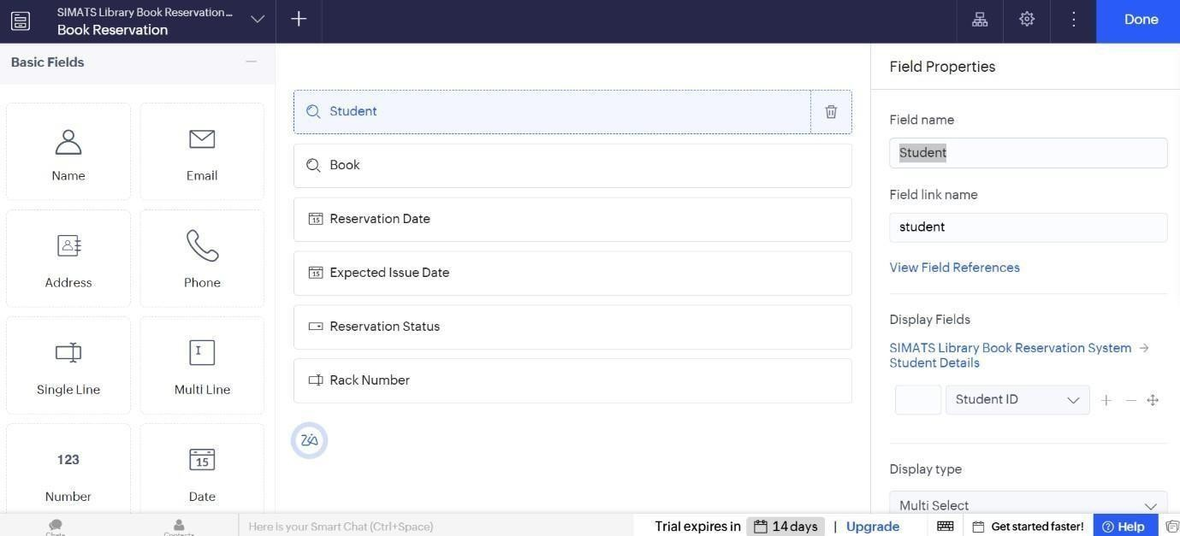

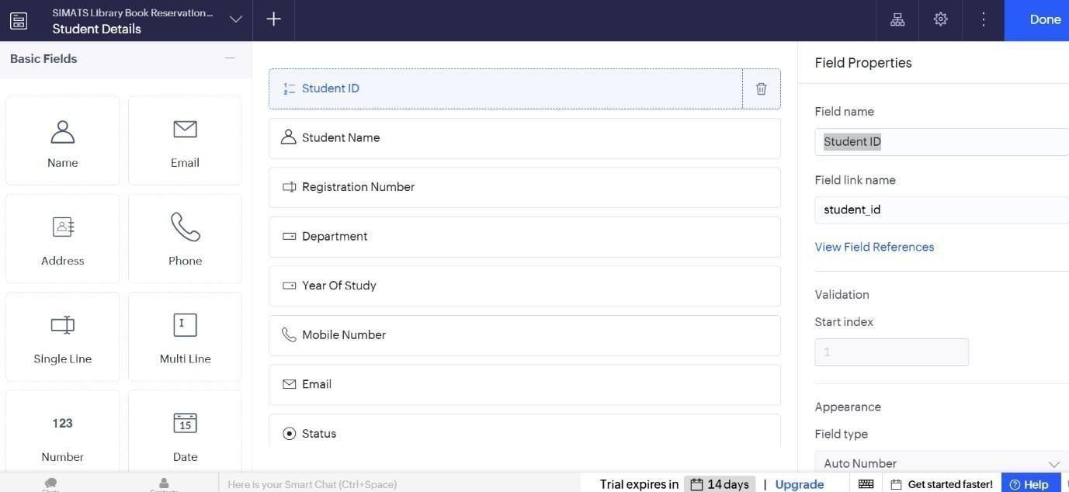
STEP 6: Create Book Reservation Form
.

STEP 7: Create Book Issue Return Form.
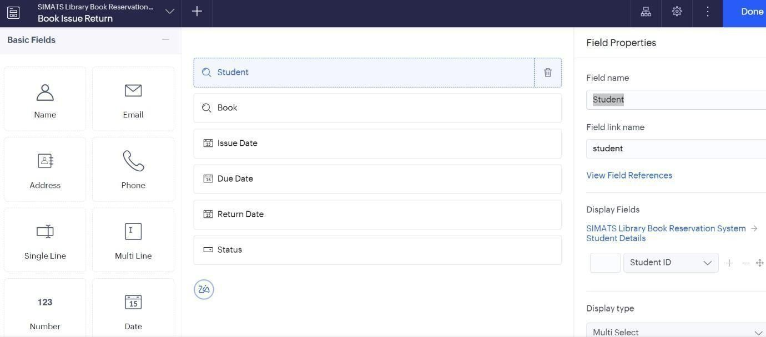

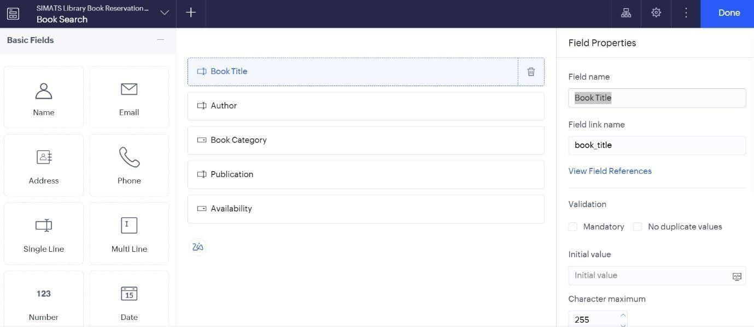

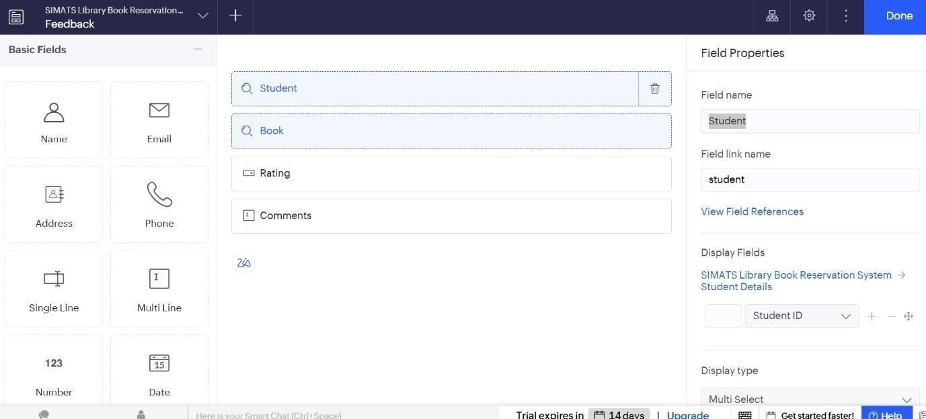
STEP 9: Create Feedback form
STEP 10: Add sample data to all the created forms.
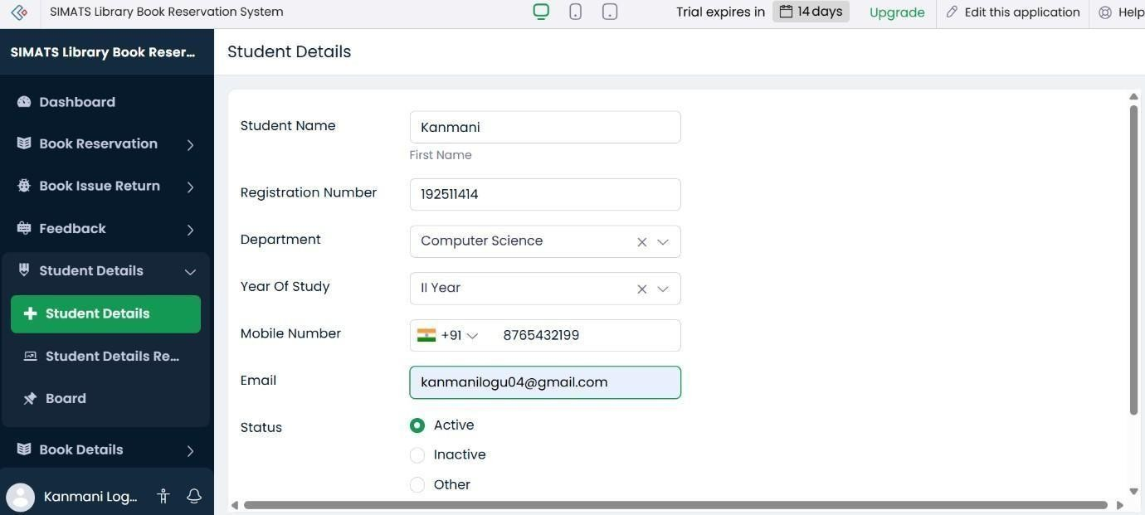

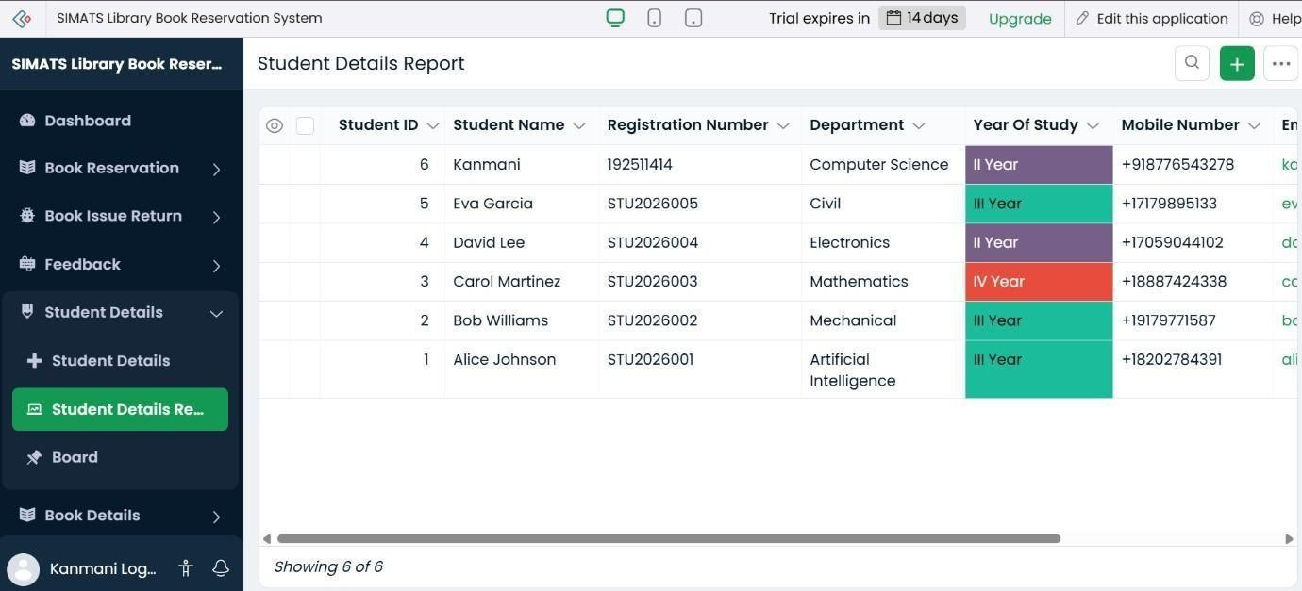

STEP 12: Create and display the Dashboard with important library information and book reservation details.
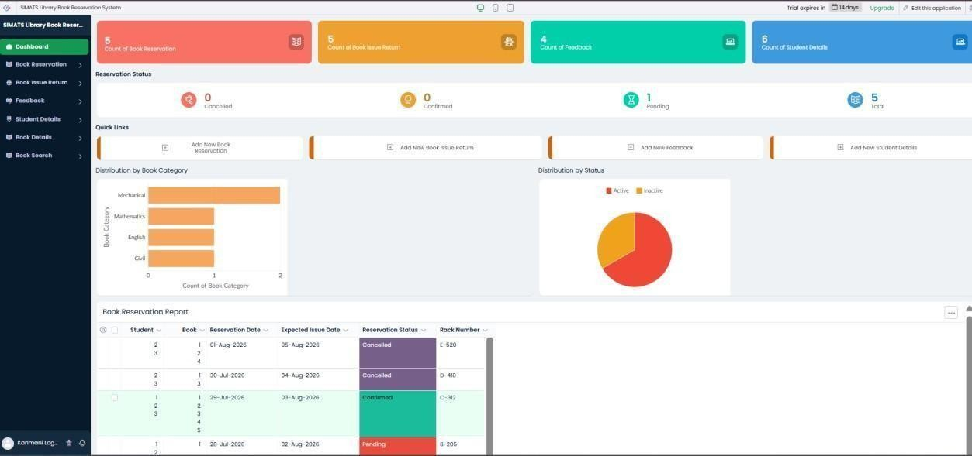2
2)Create a simple cloud software application for Payroll Processing System using any Cloud Service Provider to demonstrate SaaS include the necessary fields such as Name of the employee, experience in present org , over all experience, basic pay, HRA, DA, TA, net pay, gross pay etc.

STEP 1: Log into zoho.com.


STEP 2: Create a new application from scratch in Zoho Creator.

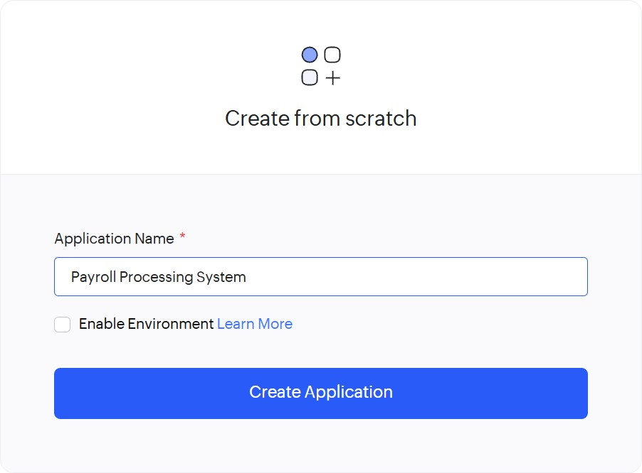
STEP 3: Create a new application and create forms from scratch.
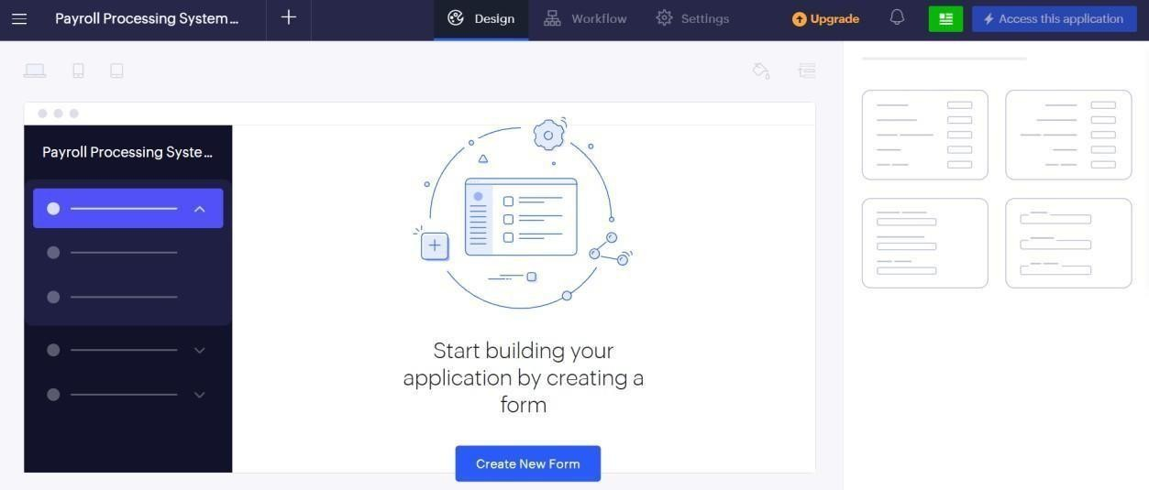

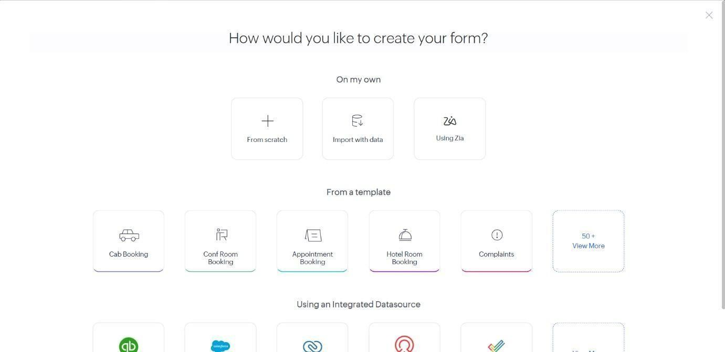

STEP 4: Create Employee Form.
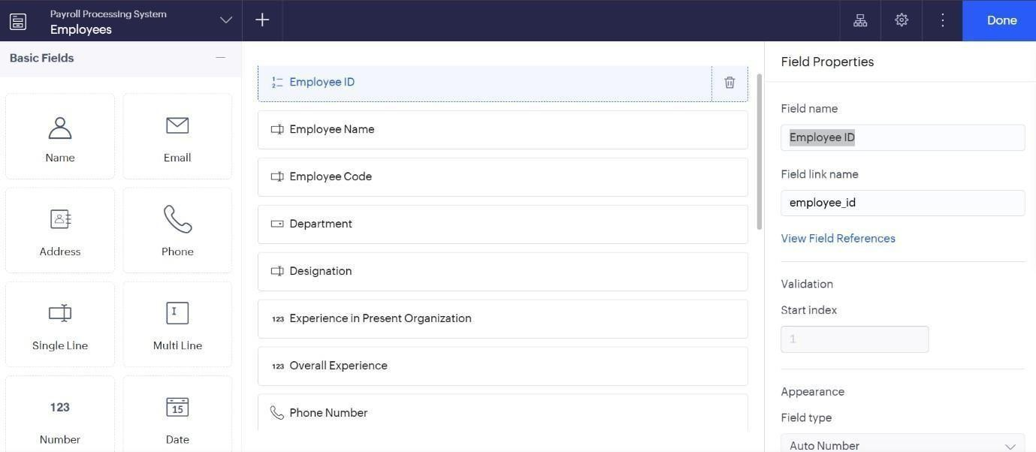
STEP 5: Create Payroll records Form.
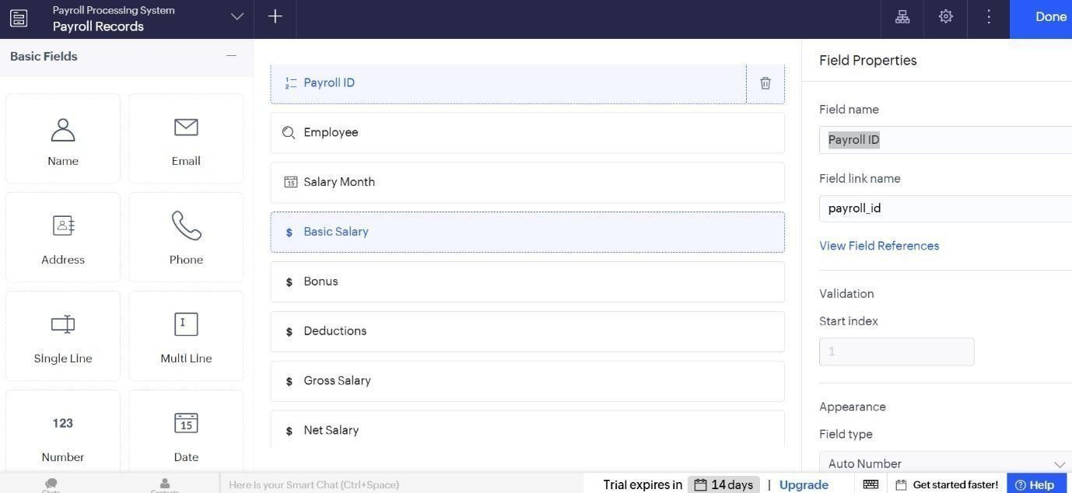
STEP 6: Create Payroll Records form
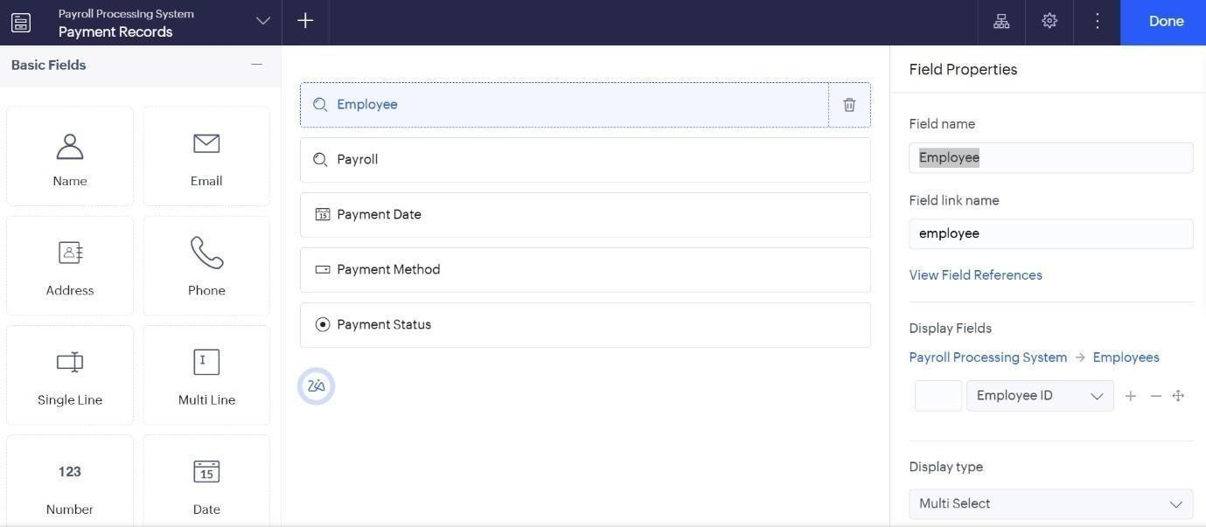
STEP 7: Create Leave records form.
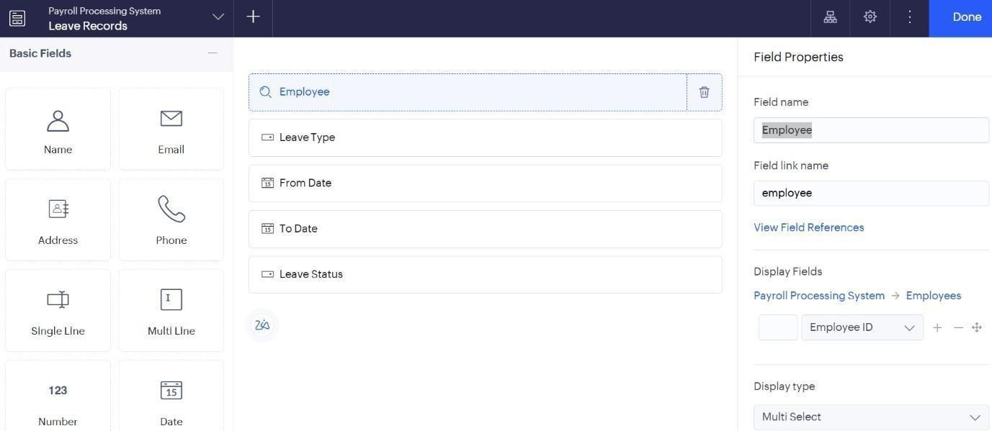
STEP 8: Add sample data to all the created forms.
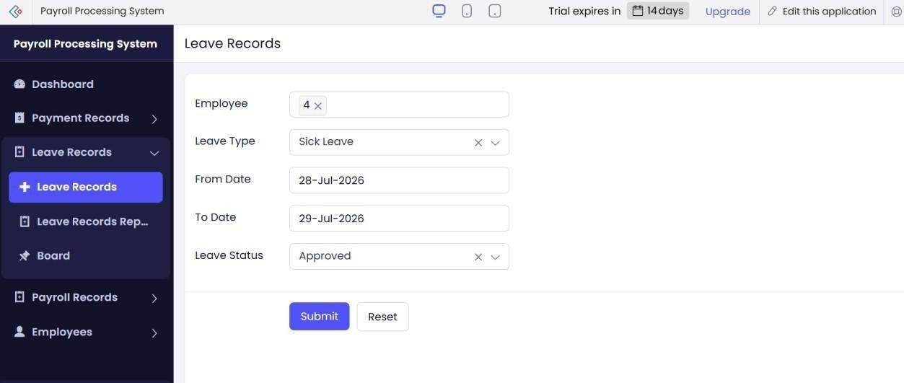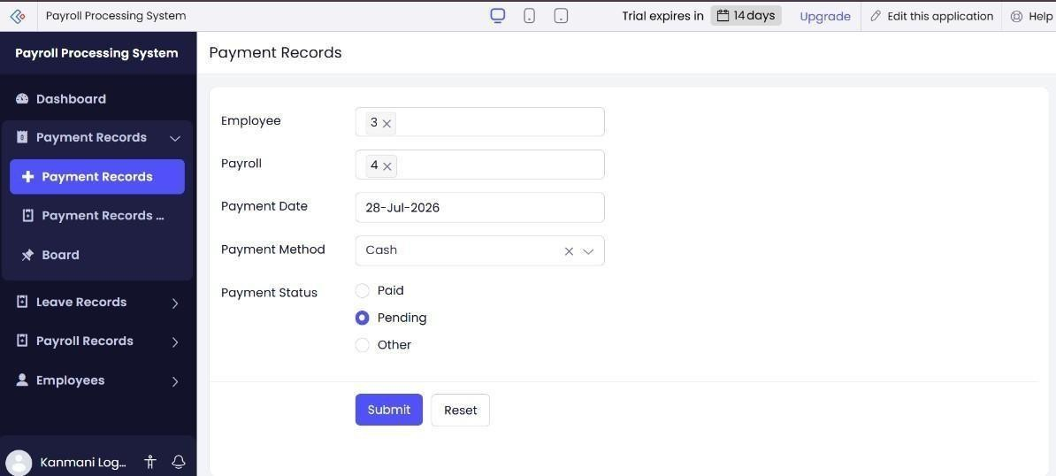

STEP 11: Create reports to display the data entered in the respective forms.

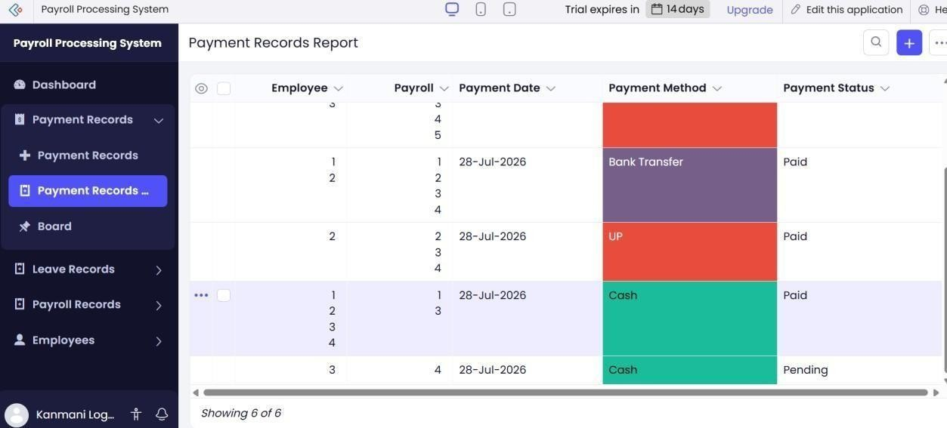

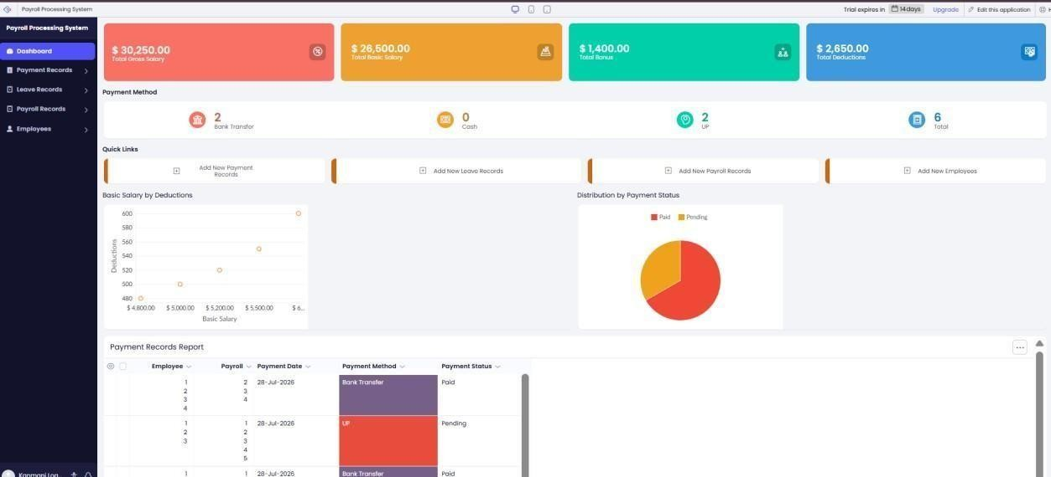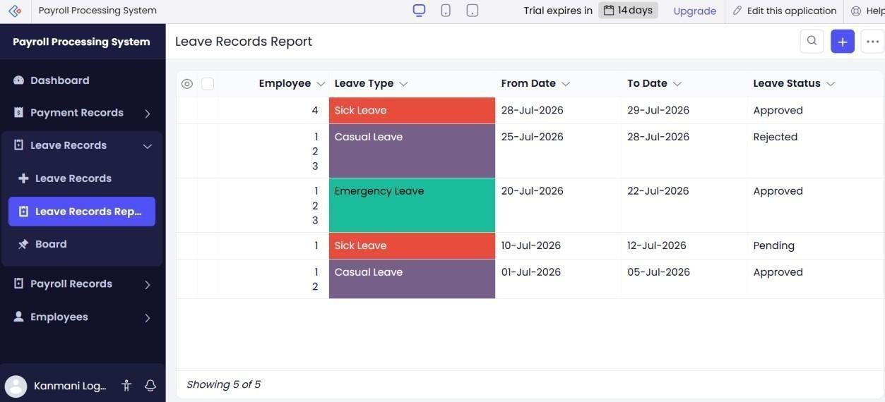

STEP

12:

Create

and

display

the
Dashboard
STEP

8:

Add

sample

data

to

all

the

created

forms.

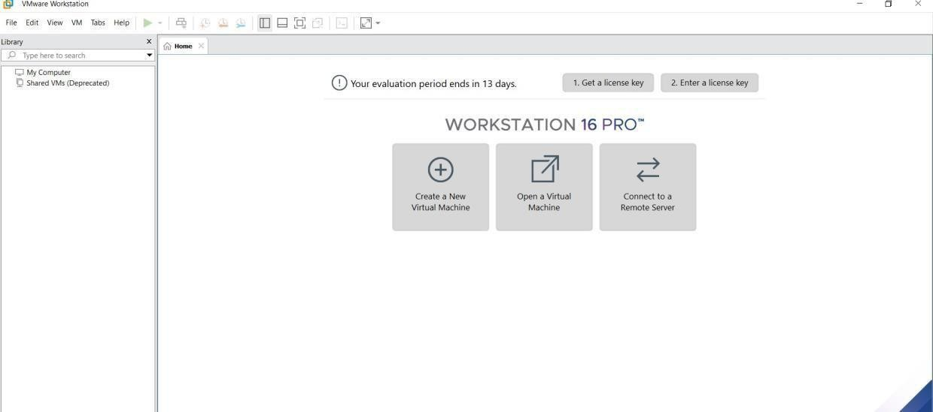
3)Demonstrate virtualization by Installing Type-2 Hypervisor in your device, create and configure VM image with a Host Operating system (Either Windows/Linux). Create a Virtual Machine with 1 CPU, 2GB RAM and 15GB storage disk using a Type 2 Virtualization Software. Sol: AIM:
To demonstrate virtualization by installing type-2 hypervisor in your device, create and configure VM image with a host operating system (either windows/linux).
PROCEDURE:
STEP 1:Dowload VMware workstation and installed as type 2hypervisor.
STEP2:Dowload ubuntu or tiny OS as iso image file.
STEP 3: In VMware workstation->create new VM.
STEP 4: Do the basic configuration settings.
STEP 5: Created tiny OS virtual machine. STEP 6: Launch the VM.
IMPLEMENTATION:
STEP 1:DOWLOAD VMWARE WORKSTATION AND INSTALLED AS TYPE 2HYPERVISOR

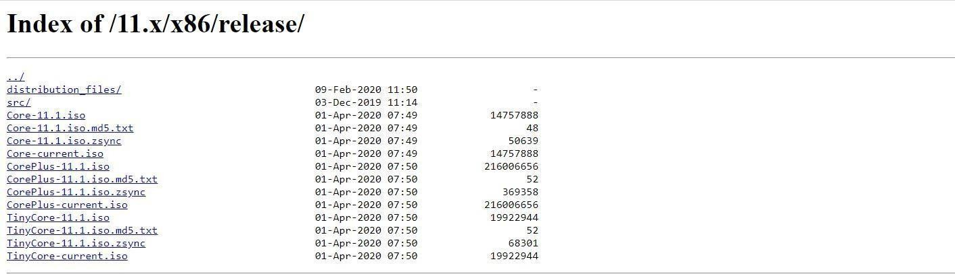
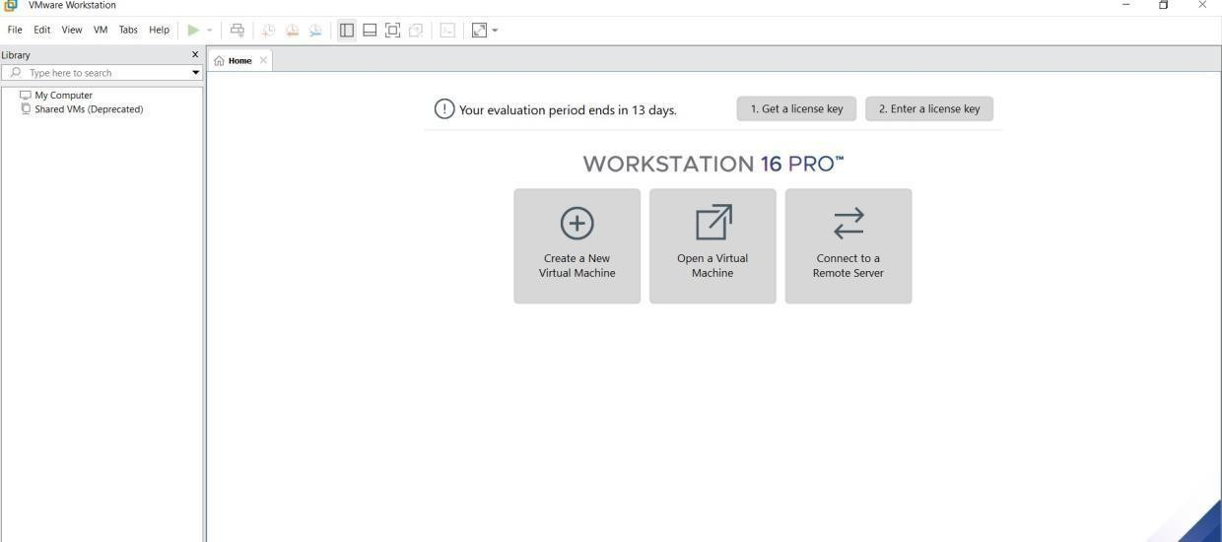
STEP 3: IN VMWARE WORKSTATION->CREATE NEW VM
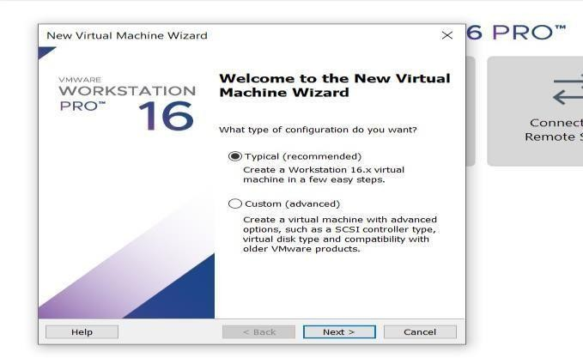

STEP 4: DO THE BASIC CONFIGURATION SETTINGS.

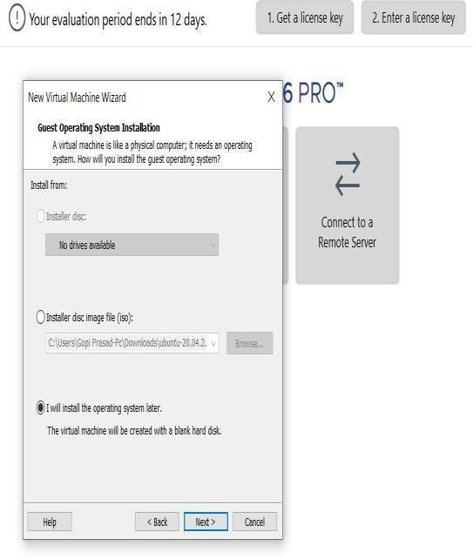
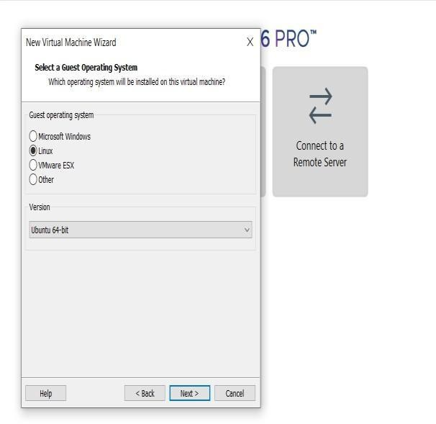
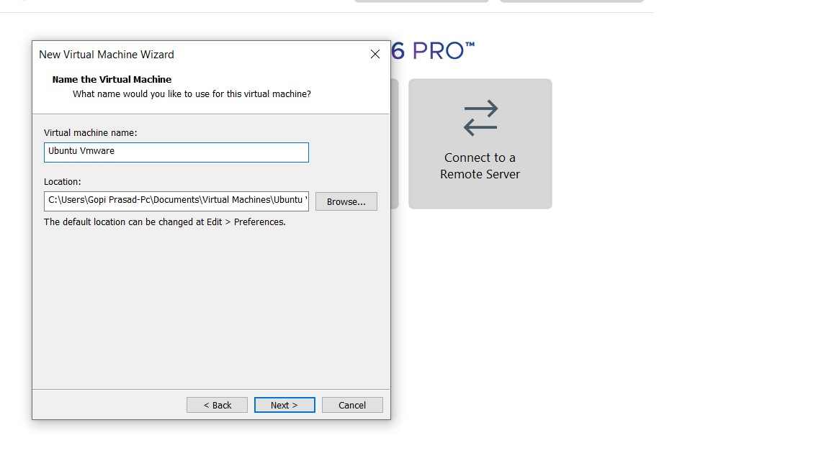
.

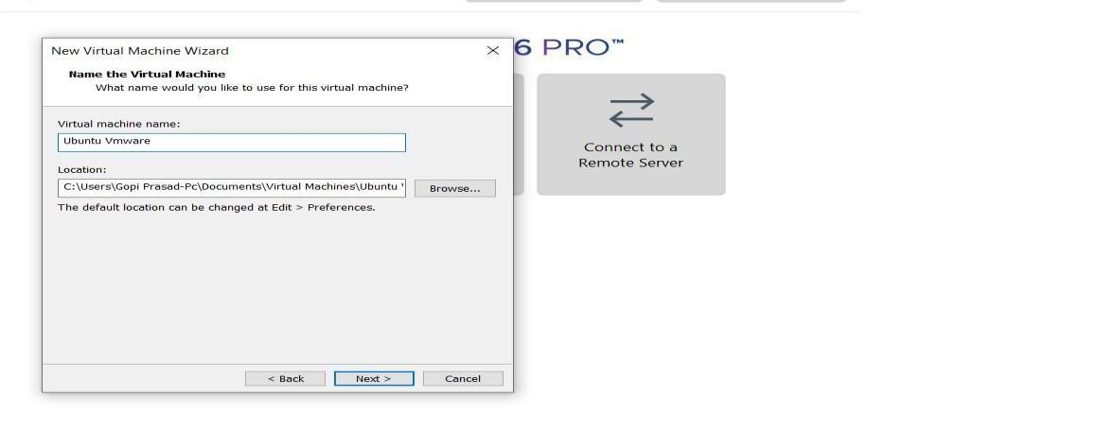

STEP

8:

Add

sample

data

to

all

the

created

forms.

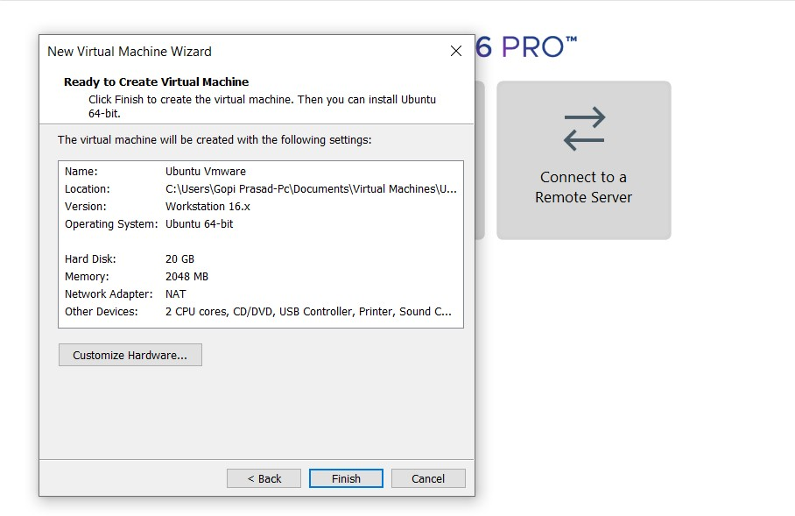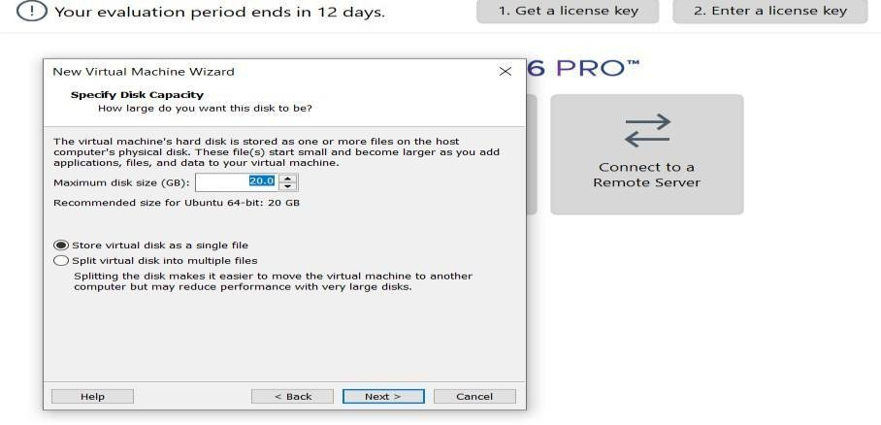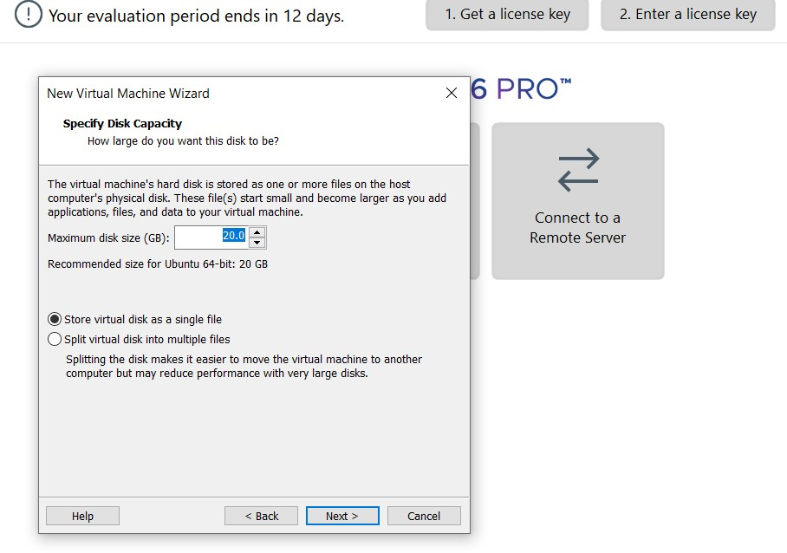
STEP 5: CREATED TINYOS VIRTUAL MACHINE

STEP 8: Add sample data to all the created forms.

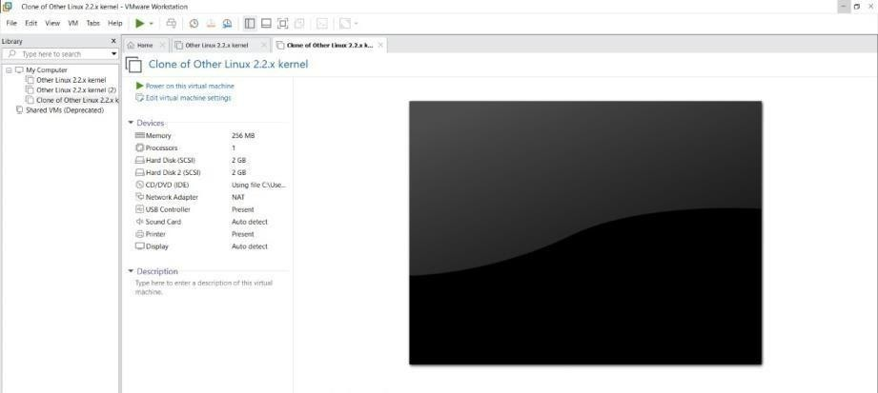

4)virtualization by Installing Type-2 Hypervisor in your device, create and configure VM image with a Host Operating system (Either Windows/Linux). Create a Cloning of a VM and Test it by loading the Previous Version/Cloned VM
Sol) AIM:
To create a virtual hard disk and allocate the storage using vm ware workstation
PROCEDURE:
STEP 1:GOTO VM WARE WORKSTATION.
STEP2: RIGHT CLICK THE VM AND GOTO THE SETTINGS.
STEP 3: ADD HARDWARE WIZARD AND SELECT SCSI AND CLICK NEXT.
STEP 4: CREATE NEW VIRTUAL DISK.
STEP 5: SELCT THE DISK SIZE AS 2.0. AND SELCT SPLIT VIRTUAL DISK INTOMULTIFILES.
STEP 6: GIVE NAME AND CLICK THE FINISHSTEP 8: Add sample data to all the created forms.
IMPLEMENTATION:
STEP 1:GOTO VM WARE WORKSTATION
STEP2: RIGHT CLICK THE VM AND GOTO THE SETTINGS

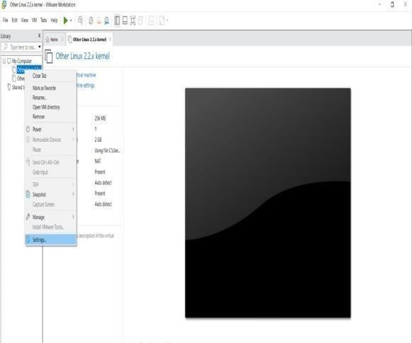

STEP 3: ADD HARDWARE WIZARD AND SELECT SCSI AND CLICK NEXT
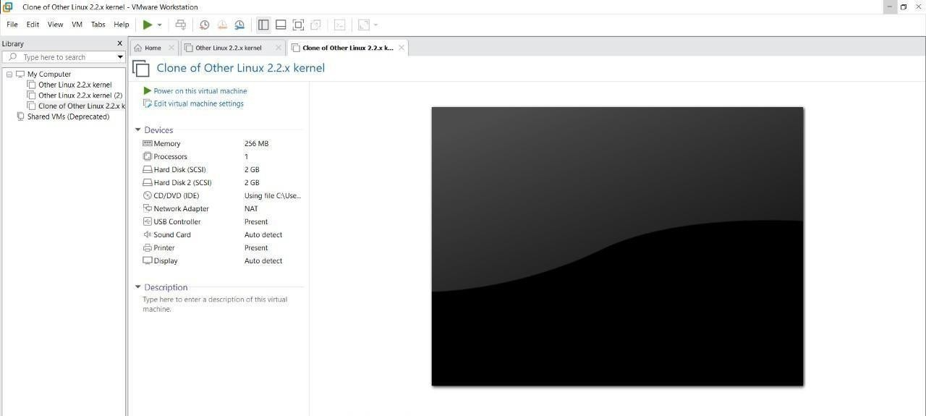
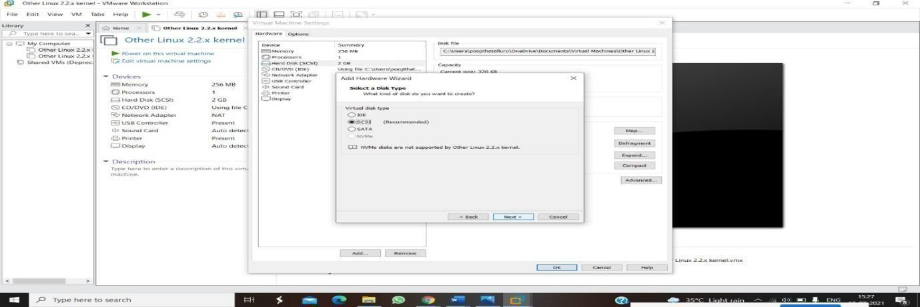
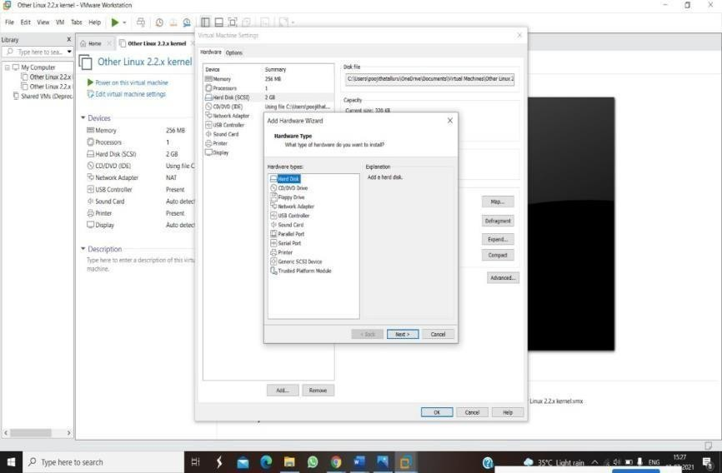
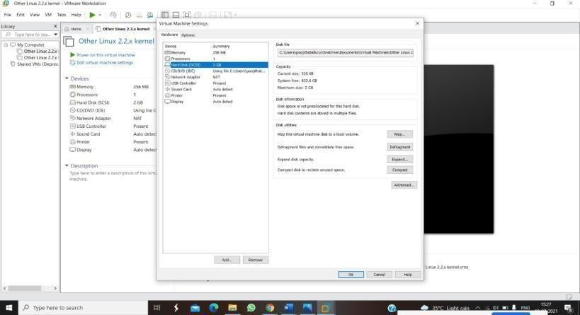
STEP 4: CREATE NEW VIRTUAL DISK

STEP 5: SELCT THE DISK SIZE AS 2.0. AND SELCT SPLIT VIRTUAL DISK INTOMULTIFILES.
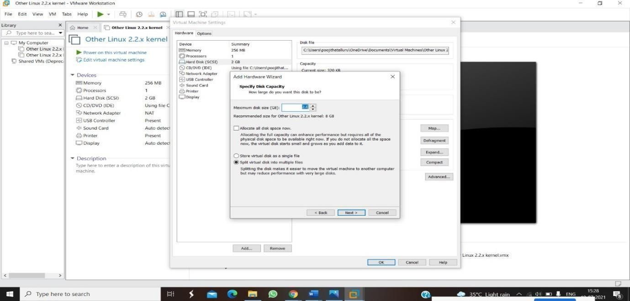
.

S

STEP 6: GIVE NAME AND CLICK THE FINISH




